Operating Systems

Assignment 3

CLO 3 - 30 Marks

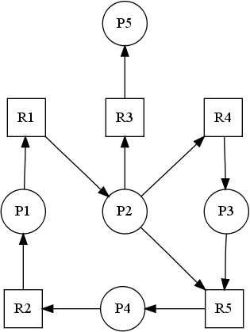
- Draw the Wait for Graph against the following resource-allocation graph and check either the system is in deadlock state.

- Apply the deadlock detection algorithm on the following resource allocation diagram, and check either the system is in deadlock state, or specify a safe allocation sequence.
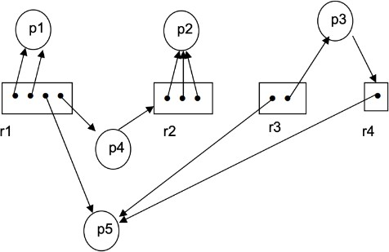
Hint: Convert the above mentioned graph into tabular format and then apply deadlock detection algorithm. Like for Process P1 and P3 the table is filled as below. Add details of other processes in it.

 | Allocation |  |  |  | Request |  |  |  | Available
 | r1 | r2 | r3 | r4 | r1 | r2 | r3 | r4 | r1 | r2 | r3 | r4
P1 | 2 | 0 | 0 | 0 | 0 | 0 | 0 | 0 | 0 | 0 | 0 | 0
P3 | 0 | 0 | 1 | 0 | 0 | 0 | 0 | 1

